Utthita Parsvokonasana – Extended Lateral Angle Pose

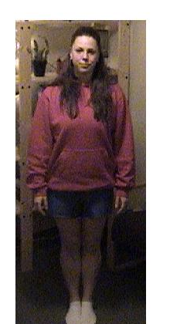  Stand in Tadasana | 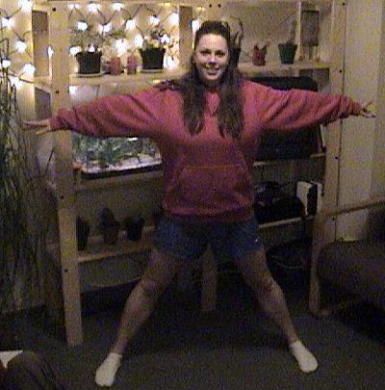  Step or jump feet 4ft apart
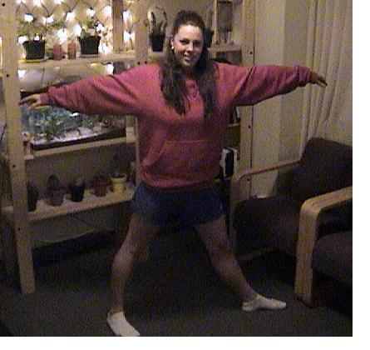  Turn right foot in 15 degrees  Turn left foot out 90 degrees (heel and arch in alignment) | 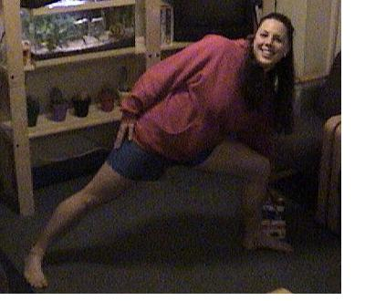  Hinge from the hip reaching toward the hip  Place hand on foam blocks beside foot  Don’t collapse the upper shoulder
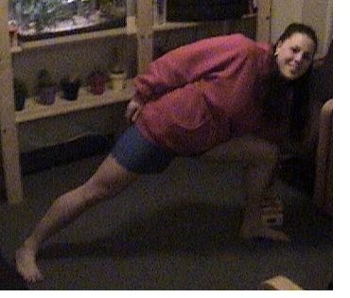  If you are comfortable use less height under the hand (goal is to eventually put hand on the floor) | 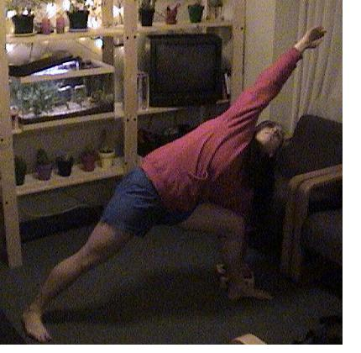  When you are confident swing arm over body  Repeat on other side

